How Do I Print a PDF Output of a Purchase Order? (Single or Batch)

☞ | NOTE: You can print a purchase order from any purchase order screen within Oracle Financials.

- Select the responsibility ‘PO Purchasing Unit User (UOM)’. Then select ‘Purchase Order Summary’ from the menu.
- Alternatively, you may have the purchase order open on your screen as shown in the example below.
- Go to ‘View’ on the toolbar then click on ‘Requests’.
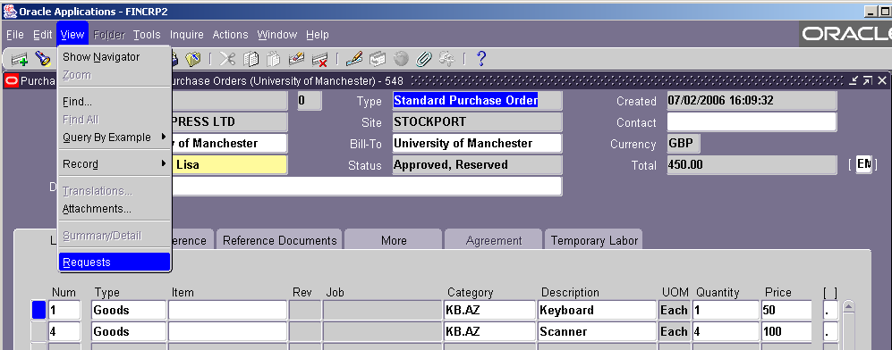

- On the ‘Find Requests’ screen that appears, click on ‘Submit a New Request’.
- The ‘Submit a New Request’ screen will default to ‘Single Request’. Click ‘OK’.
- Enter ‘XXUOM P%’ in the ‘Name’ field then press the Return key on your keyboard.
- From the list that appears, select ‘XXUOM Purchase Order Report (PDF)’.
- You may see an ‘Error’ message. This is making sure you don’t forget to say which purchase orders you want to print (these are called the ‘Parameters’). Click ‘OK’.
- Set the Parameters by completing the fields shown below. (These are all explained overleaf).
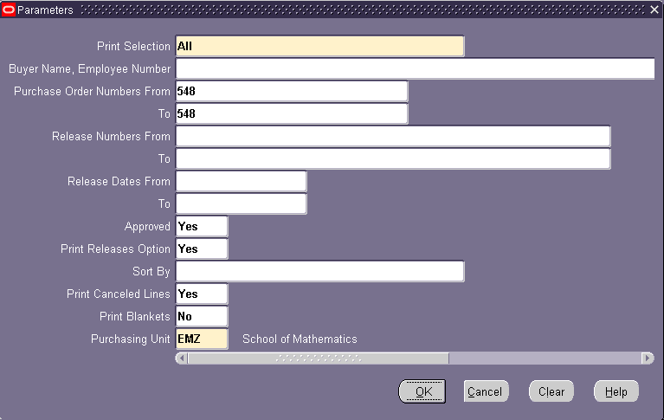

Field Name | Description
Print Selection | Enter the word ‘All’ or ‘A’
Purchase Order Numbers From | SINGLE: Enter the purchase order number you want to print  BATCH: Enter the first purchase order number you want to print
To | SINGLE: Enter the purchase order number you want to print  BATCH: Enter the last purchase order number you want to
Approved | Enter the word ‘Yes’ or ‘Y’
Purchasing Unit | Enter your purchasing unit e.g. EMZ. Use the three dots to search if you don’t know your purchasing unit.

- Click ‘OK’. You’ll return to the ‘Submit Request’ screen. Click ‘Submit’.
- You’ll now see a ‘Requests’ screen. Click ‘Refresh Data’. The ‘Phase’ will change and will show as: Pending, Running, Completed.
- When the Status says ‘Completed’, click ‘View Output’. This opens the PDF document and shows the purchase order as in the example shown below.

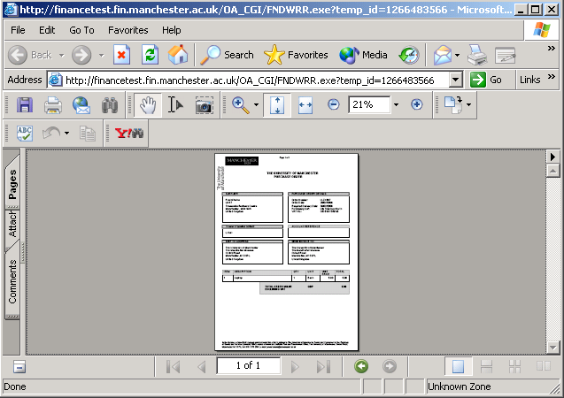
What if the purchase order is not shown?
- Check if ‘Suppress PO Print’ is set to ‘Yes’. Click on the flex field to check. If this field is set to ‘Yes’, change it to ‘No’ or leave the field blank.
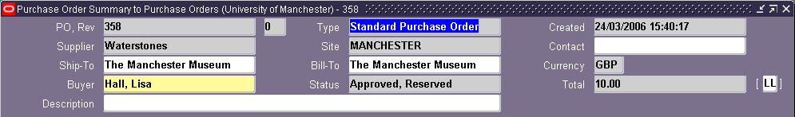
- Check if the purchase order is complete. The ‘Status’ should say ‘Approved, Reserved’.

