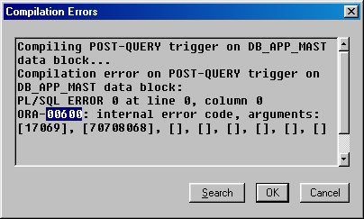
Transaction: - Rep_t.fmb

TR_data.fmb.

ORA-00600 internal error code, arguments: [string], [string], [string], [string], [string], [string], [string], [string]
Cause: This is the generic internal error number for Oracle program exceptions. It indicates that a process has encountered a low-level, unexpected condition. Causes of this message include:
- timeouts
- file corruption
- failed data checks in memory
- hardware, memory, or I/O errors
- incorrectly restored files
The first argument is the internal message number. Other arguments are various numbers, names, and character strings. The numbers may change meanings between different versions of Oracle.
Action: Report this error to Oracle Customer Support after gathering the following information:
- events that led up to the error
- the operations that were attempted that led to the error
- the conditions of the operating system and databases at the time of the error
- any unusual circumstances that occurred before receiving the ORA-00600 message
- contents of any trace files generated by the error
- the relevant portions of the Alter files
Note: The cause of this message may manifest itself as different errors at different times. Be aware of the history of errors that occurred before this internal error.

